Instructions to connect to elluminate sessions of CIsis + ABCD presentations

To view the Elluminate presentations follow these steps. It is very simple. Just be patient the first time you connect to the elluminate because this program will cehck your version of Java and, if necessary will update it in your PC. This may take 2 – 3 minutes, but this should be done the first time you connect, the rest of the week it will be faster

Connect to this URL:
https://sas.elluminate.com/m.jnlp?sid=1110&password=M.01E9FBF9B44426B3DA83CF756B7C23

!) this is the connection page, give a nickname, like the example
tip: use your name and country, so we can identify who is the person, I am using ernesto/uy
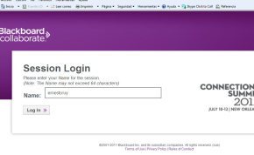

2) The system will check for your version of Java, and if your PC has an old version, will ask you permission to upgrade it,
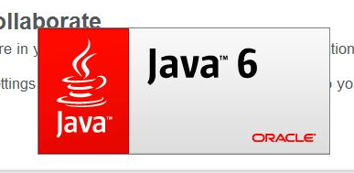

3) after the upgrade Java will proceed to prepare your PC to the session
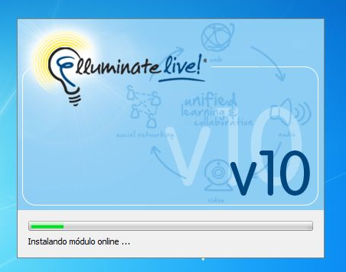

4) when it is ready will open the session
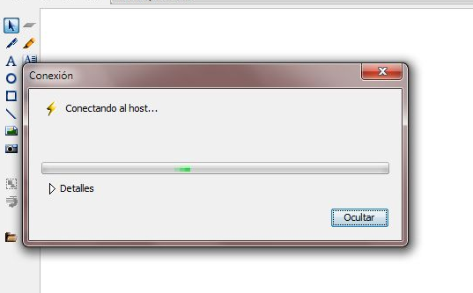

5) Ready , you are logged in. Follow the tips explained at the left column

