The spaces in v100 * 4 do not exist. They were included when I copied it to the email.
It is not a hyperlink in a pft. It's in the Workshied, where I use an author DB (autoridades.pft) picklist like this:
In the autor database, I have, for example, the following record:
100 ®1#^aNonê, ^d1914-1972^xAcervo¯
400 ®1#^aJosé Oswald Antonio de Andrade.¯
400 ®1#^aAndrade, José Oswald Antonio de.¯
400 ®##^aAndrade Filho, Oswald de.¯
Where field 100 is the name to be used, but there are 3 name variations, and the cataloger does not know which one is the . The cataloger clicks the glass icon of the workshied as shown below.
which will open the picklist of all of the autor database names and, as the cataloger does not know the correct name, looks for "Andrade Filho, Osvaldo de" as shown below:
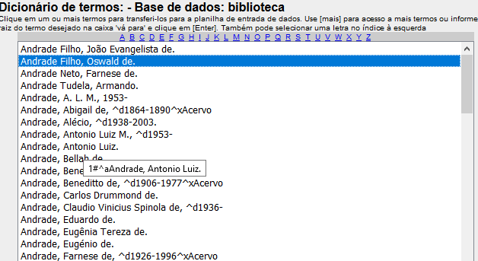
Instead of assigning the name of field 100 "aNonê, ^d1914-1972 ^xAcervo", it assigns that of the 400 field itself: that is,
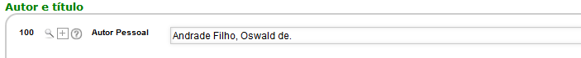
If, instead of the third occurrence of field 400, the catalog clicks on the name of the first occurrence, in case
400 ®1#^aJosé Oswald Antonio de Andrade.¯
It will assingn de content of field 100.

